https://docs.redhat.com/en/documentation/red_hat_openshift_data_foundation/4.9/html/planning_your_deployment/odf-architecture_rhodf

Red Hat OpenShift Data Foundation (ODF)—formerly known as OpenShift Container Storage—is a software-defined, cloud-native storage solution built specifically for containerized environments. It is powered by open-source technologies like Ceph (for distributed storage), Rook (for storage orchestration), and NooBaa (for the Multicloud Object Gateway).
When paired with OpenShift Virtualization (which allows you to run traditional Virtual Machines alongside containers on the same cluster), ODF acts as the hyper-converged storage engine. Instead of requiring a separate, traditional SAN/NAS for VMs and another storage system for containers, ODF unifies them, enabling OpenShift to manage VM disks just like native Kubernetes persistent volumes.
Key Features of ODF on OpenShift Virtualization
- Unified Multi-Protocol Storage: Provides Block storage (ideal for VM boot disks and databases), File storage (for shared filesystems across VMs/containers), and Object storage (S3-compatible for backups and data lakes).
- Smart Cloning and Instant Snapshots: Leverages Container Storage Interface (CSI) capabilities to allow administrators to instantly snapshot VM states or clone virtual machines without duplicating the underlying data blocks immediately.
- Live Migration Support: ODF supports ReadWriteMany (RWX) block and file storage. This is the crucial prerequisite that allows a running Virtual Machine to live-migrate from one physical OpenShift node to another without any downtime.
- Multicloud Object Gateway (NooBaa): Allows you to federate and mirror object storage across different public clouds or on-premise datacenters seamlessly.
- Built-in Data Resiliency: Features built-in data replication (typically a 3-way replica) and erasure coding across failure domains to ensure that a disk or node failure doesn't take down your VMs.
- Robust Security & Encryption: Provides cluster-wide and persistent-volume-level encryption (using AES-256) integrated with external Key Management Systems (KMS).
Benefits
- Single Control Plane (Hyper-convergence): You manage your VMs, containers, network, and storage from a single OpenShift console. There's no need to switch between VMware vCenter and a separate storage array management UI.
- Infrastructure Agnostic: ODF abstracts the underlying hardware. Whether your OpenShift cluster is running on bare metal, AWS, Azure, Google Cloud, or Oracle Cloud, your VMs interact with storage the exact same way.
- Simplified VM Operations: Activities like expanding a VM's hard drive are as simple as changing a number in a YAML file or hitting "expand" in the OpenShift UI. The system handles the underlying Ceph volume resizing automatically.
- Enhanced DR and Business Continuity: Advanced editions offer metro (sync) and regional (async) disaster recovery, enabling automated failovers of VMs to a secondary site.
- Cost Efficiency: Eliminates the licensing costs of proprietary virtualization storage layers (like VMware vSAN) by using open-source, enterprise-supported software-defined storage.
Cons and Challenges
- High Resource Consumption (The "Tax"): Because ODF is software-defined and runs directly on your OpenShift worker nodes (in internal mode), it consumes a noticeable amount of CPU and RAM. Red Hat typically recommends a minimum of 16 vCPUs and 64GB of RAM per storage node.
- Steep Learning Curve: Under the hood, ODF relies heavily on Ceph. If something goes deeply wrong with the storage cluster, troubleshooting requires understanding complex Ceph concepts (OSDs, placement groups, CRUSH maps), which can intimidate traditional virtualization admins.
- UI/UX Limitations: While the OpenShift console is robust, advanced storage tweaks and day-two operations still occasionally require diving into command-line scripting or writing raw YAML files.
- Performance Overhead: While highly optimized, software-defined storage running over a network overlay can sometimes introduce slight latency overhead compared to a dedicated, high-end hardware SAN directly attached via Fibre Channel.

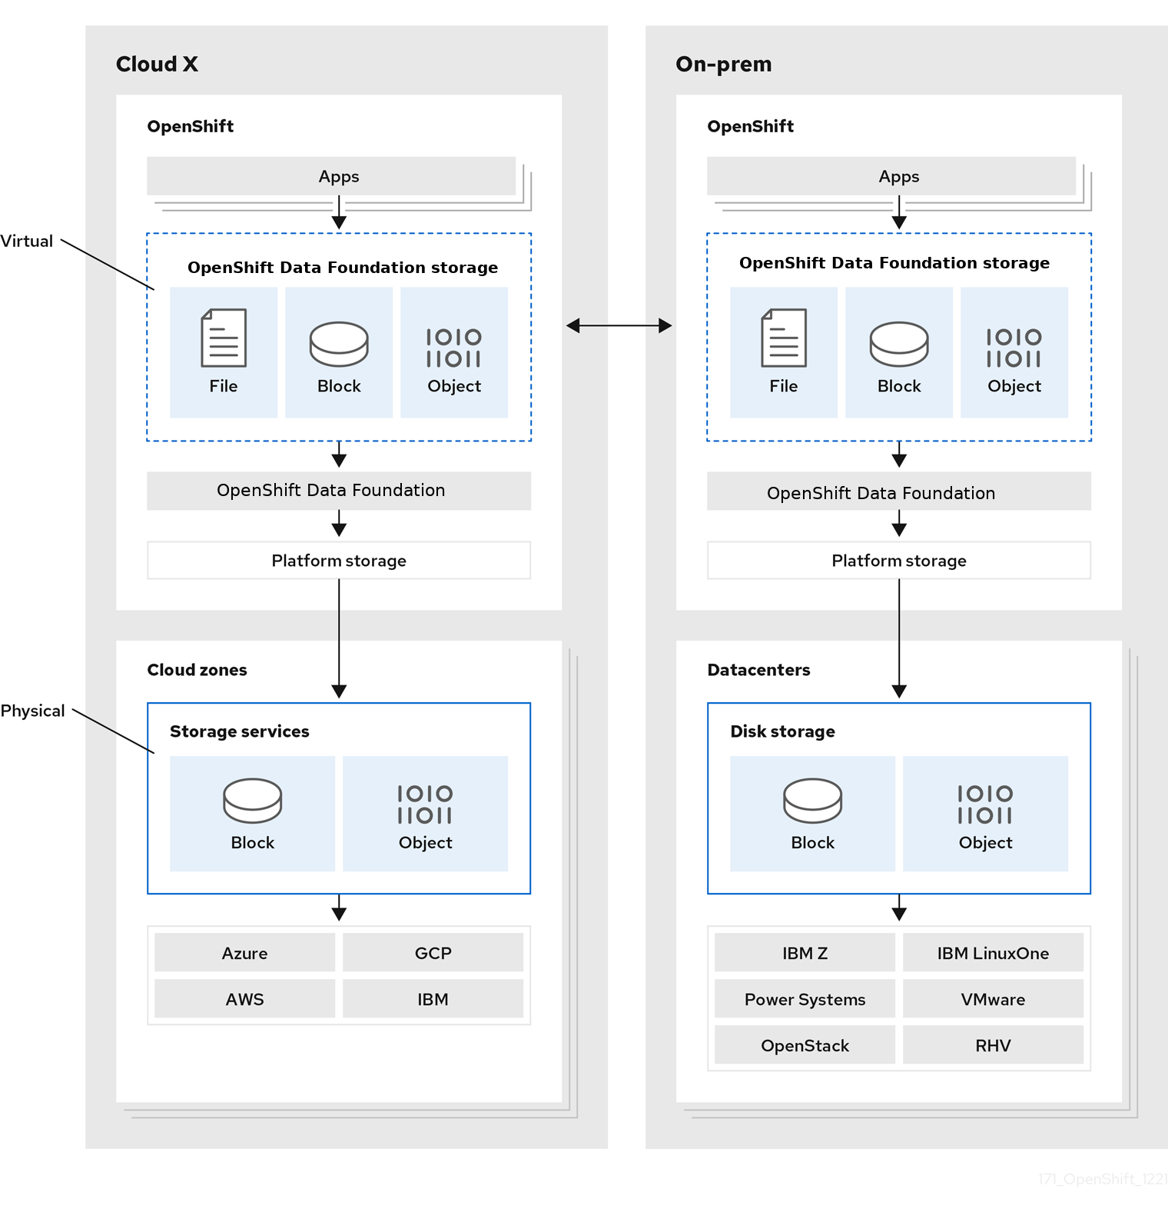

OpenShift Data Foundation (ODF), formerly known as OpenShift Container Storage (OCS), is Red Hat’s unified and software-defined storage solution for OpenShift environments. It enables persistent storage for containers, integrated backup and disaster recovery, and multicloud data management.

One of the most common deployment methods for ODF is Internal Mode, where the storage devices are hosted within the OpenShift cluster itself — ideal for small to medium-scale deployments.
Architecture Overview: Internal Mode
In Internal Mode, OpenShift Data Foundation relies on Ceph — a highly scalable storage system — and utilizes three core components:
- Rook Operator
Handles deployment and lifecycle management of Ceph clusters inside Kubernetes.
- Ceph Cluster (Mon, OSD, MGR, etc.)
Provides object, block, and file storage using the available storage devices on OpenShift nodes.
- NooBaa
Manages object storage interfaces (S3-compatible) and acts as a data abstraction layer for multicloud object storage.
Core Storage Layers:
- Object Storage Daemons (OSDs): Store actual data and replicate across nodes for redundancy.
- Monitor (MON): Ensures consistency and cluster health.
- Manager (MGR): Provides metrics, dashboard, and cluster management.
Key Benefits of Internal Mode
- No need for external storage infrastructure.
- Faster to deploy and manage via OpenShift Console.
- Built-in replication and self-healing mechanisms.
- Ideal for lab environments, edge, or dev/test clusters.
Deployment Prerequisites
- OpenShift 4.10+ cluster with minimum 3 worker nodes, each with:
- At least 16 CPU cores and 64 GB RAM.
- At least one unused raw block device (no partitions or file systems).
- Internet connectivity or local OperatorHub mirror.
- Persistent worker node roles (not shared with infra/control plane).
🔧 Steps to Deploy ODF in Internal Mode
1. Install ODF Operator
- Go to OperatorHub in the OpenShift Console.
- Search and install OpenShift Data Foundation Operator in the appropriate namespace.
2. Create StorageCluster
- Use the ODF Console to create a new StorageCluster.
- Select Internal Mode.
- Choose eligible nodes and raw devices.
- Validate and apply.
3. Monitor Cluster Health
- Access the ODF dashboard from the OpenShift Console.
- Verify the status of MON, OSD, and MGR components.
- Monitor used and available capacity.
4. Create Storage Classes
- Default storage classes (like ocs-storagecluster-ceph-rbd, ocs-storagecluster-cephfs) are auto-created.
- Use these classes in PVCs for your applications.
Use Cases Supported
- Stateful Applications: Databases (PostgreSQL, MongoDB), Kafka, ElasticSearch.
- CI/CD Pipelines requiring persistent storage.
- Backup and Disaster Recovery via ODF and ACM.
- AI/ML Workloads needing large-scale data persistence.
Best Practices
- Label nodes intended for storage to prevent scheduling other workloads.
- Always monitor disk health and usage via the dashboard.
- Regularly test failover and recovery scenarios.
- For production, consider External Mode or Multicloud Gateway for advanced scalability.

In the context of IBM Storage Fusion running on OpenShift, data cataloging is handled by a specialized component called IBM Storage Fusion Data Cataloging (formerly known as IBM Spectrum Discover).
Its primary purpose is to provide complete metadata management, visibility, and governance over massive amounts of unstructured data (files and objects) scattered across your enterprise, whether that data lives on-premise, in cloud-native OpenShift storage (like ODF), or on legacy storage arrays.
Think of it as an automated, hyper-fast search engine and compliance auditor for your enterprise data footprint.
The Core Purposes of Data Cataloging
1. Breaking Down Data Silos (Unified Visibility)
Enterprises often have petabytes of data spread across different storage tiers: OpenShift Data Foundation (ODF), IBM Storage Scale, AWS S3, or traditional NFS shares. Data Cataloging connects to all these heterogeneous storage sources, ingests their metadata, and creates a single, centralized catalog. This allows administrators and data scientists to see and query all data assets from a single pane of glass without moving the actual data.
2. Automated Metadata Enrichment
Standard storage systems track basic system metadata (file name, size, creation date, owner). IBM Storage Fusion Data Cataloging goes a step further by:
- Instantly indexing this system metadata at massive scale (millions of files in minutes).
- Allowing organizations to add custom metadata tags (e.g., tagging data with Project: Alpha, Data_Owner: Finance, or Classification: Restricted).
- Using deep inspection to extract content-based metadata, making unstructured data "discoverable."
3. Data Governance and Compliance (PII / GDPR / HIPAA)
With strict regulatory frameworks, companies must know exactly where sensitive data resides. Data Cataloging includes built-in classification engines that scan files for sensitive patterns like Credit Card Numbers, Social Security Numbers, or healthcare records.
- The Purpose: It automatically flags non-compliant data, unencrypted sensitive files, or data stored in unauthorized locations so compliance officers can take immediate action.
4. Storage Optimization and Cost Reduction
Unstructured data grows exponentially, and much of it becomes "cold" (unaccessed) or redundant. Data Cataloging provides deep analytics to identify:
- ROT Data: Redundant, Obsolete, and Trivial data (e.g., duplicate files, 5-year-old log files, or employee holiday photos).
- Orphaned Data: Files owned by employees who have left the organization. By identifying this data, IT administrators can create automated workflows to archive cold data to cheaper object storage or delete redundant files, drastically reducing primary storage costs.
5. Accelerating AI and Data Science Pipelines
Data scientists spend up to 80% of their time just finding and cleaning data. Because IBM Storage Fusion is tightly integrated with OpenShift, the Data Catalog serves as a bridge to AI platforms like IBM watsonx or Red Hat OpenShift AI.
- Data scientists can use the catalog to quickly search and filter specific datasets (e.g., "Find all curated MRI images from Q3 labeled 'clean'").
- Once found, they can feed those precise data paths directly into their AI/ML training models.
Technical Workflow: How it Works on OpenShift
- Inbound Connection: Data Cataloging deploys as containerized microservices on OpenShift. It connects to storage providers via lightweight connectors.
- Fast Scanning: Instead of scanning the heavy contents of every file repeatedly, it hooks into the storage system's internal metadata notifications (like Ceph or IBM Storage Scale change logs) to keep the catalog updated in near real-time.
- Database Indexing: It compiles this data into an optimized metadata database running natively on the OpenShift cluster.
- Actionable Insights: Users interact with the data through a graphical dashboard, REST APIs, or SQL-like queries to generate compliance reports, optimize storage, or curate data for applications.

